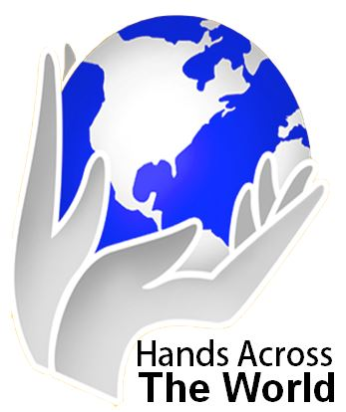
1605 Goettens Way, Suite 206; St Cloud, MN 56301 320.260.1072
info@handsacrosstheworldmn.org www.handsacrosstheworldmn.org

Hands Across the World
Volunteer Mandating Reporter Acknowledgment Form
Welcome and thank you for taking time out of your busy schedule to volunteer with Hands Across the World! While volunteering at Hands Across the World, you will be in contact with children. Being in contact with children requires a big responsibility from volunteers. While being a volunteer and allowing you to work with the children at our agency, you automatically become a mandated reporter.
A mandated reporter is someone who needs to report any and all signs of child abuse, sexual abuse, or child neglect to relevant authorities. While being a volunteer at Hands Across the World, the first step that you would take if you suspect child abuse, sexual abuse, or child neglect would be immediately to tell the executive director Brianda Cediel, and to make a report. If you do not feel comfortable approaching the supervisor, you can just make the report to local authorities.
Verbal reports must be made immediately. A written report must be submitted within 72 hours. Reports should be made to the local child welfare agency. Local child welfare agencies in our area include, Stearns, Benton, and Sherburne.
Indicators of child abuse/neglect include but are not limited to:
- Unexplained bruises, bite marks, broken bones, burn marks or black eyes
- Seems frightened by parents and cries when it is time to leave
- Shrinks at the approach of adults
- Child reports an injury from parent or caregiver
- Child looks unhealthy from maltreatment
- Child is dirty and has strong foul body odors
- Sudden and severe behavior changes in the child
Indicators of sexual abuse include but are not limited to:
- Difficulty sitting or walking
- Becomes secretive or isolated
- Reports sexual abuse from parent or caregiver
The well-being of the children at our agency is our #1 priority. With that being said, we would like to touch base on mental health. If you notice a significant behavior change in a child or if the child seems down, it could be for various reasons. Maybe that child is being bullied at school or maybe they are not happy about something that is happening at home. It is okay to take time out of whatever you are doing and make sure that the child is alright. Sometimes all a child needs is someone to talk too! If the child opens up to you about something they are dealing with, make sure to let them know that you are there for them and they can always talk to you about things that may be upsetting them.
If you have any questions regarding mandating reporting or what should be done in certain situations, please do not hesitate to ask questions. This is a very serious responsibility and we want our volunteers to feel comfortable in taking part in our children’s lives.

Your signature below indicates that you have read the above information and understand your duties and responsibilities with mandated reporting as a volunteer at Hands Across the World.

Volunteer Name (Please Print): ________________________________________________
Volunteer Signature: ____________________________ Date: _____________________
Volunteer Supervisor: ___________________________ Date: _____________________

